**BIOINFORMATICS PROJECT 3 - Network Biology**

Group 9, Hassan Ismail, Alessandra Grise, Nagham Almagout

**Scope of the project:**

Starting from the seed genes interactome (SGI), the intersection (I) and the union (U)

interactomes built in the first part of the project, compute the main network measures for I,

U and their nodes, apply clustering methods for disease modules discovery, carry on an

enrichment analysis on the putative disease modules and produce a short report.

**Point** **1) Calculate the main network measures for SGI, I and U**

* No. of nodes of the intersection: 136 , No. of nodes of the union: 2243
* No. of links of the intersection: 149 , No. of links of the union: 3668
* No. of connected components of the intersection: 3, No. of connected components of the union: 1
* No. of isolated nodes of intersection and union: 0
* Average path length of the intersection: 2.9203117144293618, Average path length of the union: 3.415190405038492
* Average degree of the intersection: 2.1911764705882355, Average degree of the union: 3.270619705751226
* Average clustering coefficient of intersection: 0.0, Average clustering coefficient of union: 0.12082862641800761
* Network diameter of intersection: 6,2,2, Network diameter of union: 6
* Network radius of intersection: 3,1,1, Network radius of union: 3
* Centralization of intersection: 0.34148696844993, Centralization of union: 0.27117266055563394



* N. of nodes of iLCC: 118
* N. of links of iLCC: 133
* Average path length of iLCC: 3.094596552223671
* Average degree of iLCC: 2.2542372881355934
* Average clustering coefficient of iLCC: 0.0
* Network diameter of iLCC: 6, radius of iLCC: 3
* Centralization of iLCC: 0.35097523559061844
* N. of nodes of uLCC: 2248
* N. of links of uLCC: 3668
* Average path length of uLCC: 3.415190405038492
* Average degree of uLCC: 3.270619705751226
* Average clustering coefficient of uLCC: 0.12082862641800761
* Network diameter of uLCC: 6, radius of uLCC: 3
* Centralization of uLCC: 0.27117266055563943

Figures of iLCC and uLCC:

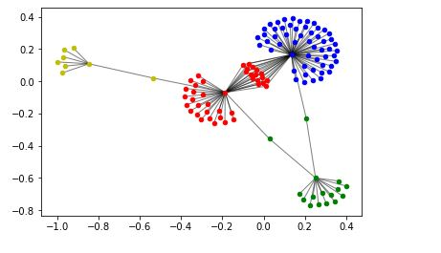

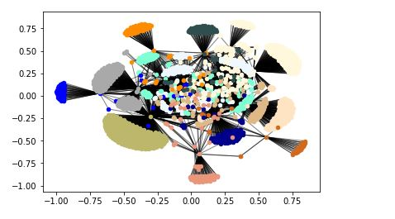

Tables:

1. uLCC

|  |  |  |  |  |  |
| --- | --- | --- | --- | --- | --- |
| node | n_degree | betweeness | eigenvector | closeness | ratio |
| Q13546 | 753 | 0.447190 | 0.592988 | 0.469038 | 0.000594 |
| P11215 | 352 | 0.194140 | 0.104879 | 0.386219 | 0.000552 |
| P19878 | 303 | 0.178568 | 0.124887 | 0.414265 | 0.000589 |
| P21580 | 398 | 0.177393 | 0.291307 | 0.422143 | 0.000446 |
| Q9Y2R2 | 235 | 0.104778 | 0.097050 | 0.356609 | 0.000446 |
| P31994 | 207 | 0.082477 | 0.097700 | 0.375356 | 0.000398 |
| P16410 | 171 | 0.070986 | 0.068033 | 0.365683 | 0.000415 |
| P29376 | 198 | 0.069632 | 0.103215 | 0.351466 | 0.000352 |
| P02741 | 120 | 0.062729 | 0.030512 | 0.354635 | 0.000523 |
| P24855 | 83 | 0.053781 | 0.008583 | 0.330971 | 0.000648 |
| O95267 | 88 | 0.053425 | 0.014301 | 0.335127 | 0.000607 |
| Q13568 | 130 | 0.050110 | 0.085114 | 0.378269 | 0.000385 |
| Q15116 | 63 | 0.042550 | 0.008264 | 0.330337 | 0.000675 |
| Q14765 | 135 | 0.041503 | 0.074109 | 0.351576 | 0.000307 |
| O60602 | 120 | 0.040603 | 0.060610 | 0.357519 | 0.000338 |
| P0C0L4 | 79 | 0.035723 | 0.013636 | 0.341925 | 0.000452 |
| P0C0L5 | 95 | 0.027904 | 0.034784 | 0.345881 | 0.000294 |
| Q9NSU2 | 36 | 0.020986 | 0.005509 | 0.270088 | 0.000583 |
| P20023 | 61 | 0.019906 | 0.020034 | 0.357177 | 0.000326 |
| P06239 | 9 | 0.014760 | 0.037650 | 0.418518 | 0.001640 |

1. iLCC:

|  |  |  |  |  |  |
| --- | --- | --- | --- | --- | --- |
| node | n_degree | betweeness | eigenvector | closeness | ratio |
| Q13546 | 70 | 0.735060 | 0.646177 | 0.527027 | 0.010501 |
| P21580 | 41 | 0.492459 | 0.286739 | 0.439850 | 0.012011 |
| Q13568 | 15 | 0.211621 | 0.015017 | 0.352410 | 0.014108 |
| O15111 | 2 | 0.128378 | 0.075289 | 0.379870 | 0.064189 |
| Q15717 | 2 | 0.113469 | 0.033116 | 0.317935 | 0.056734 |
| P16410 | 7 | 0.100354 | 0.004089 | 0.247881 | 0.014336 |
| Q9Y4K3 | 2 | 0.082800 | 0.034360 | 0.332386 | 0.041400 |
| P50591 | 2 | 0.016661 | 0.106229 | 0.430147 | 0.008330 |
| Q8IVM0 | 2 | 0.016661 | 0.106229 | 0.430147 | 0.008330 |
| Q96EP0 | 2 | 0.016661 | 0.106229 | 0.430147 | 0.008330 |
| P01375 | 2 | 0.016661 | 0.106229 | 0.430147 | 0.008330 |
| Q13490 | 2 | 0.016661 | 0.106229 | 0.430147 | 0.008330 |
| O14763 | 2 | 0.016661 | 0.106229 | 0.430147 | 0.008330 |
| Q9HC29 | 2 | 0.016661 | 0.106229 | 0.430147 | 0.008330 |
| Q9Y3C5 | 2 | 0.016661 | 0.106229 | 0.430147 | 0.008330 |
| P0CG48 | 2 | 0.016661 | 0.106229 | 0.430147 | 0.008330 |
| Q8IUC6 | 2 | 0.016661 | 0.106229 | 0.430147 | 0.008330 |
| Q14790 | 2 | 0.016661 | 0.106229 | 0.430147 | 0.008330 |
| Q9Y6K9 | 2 | 0.016661 | 0.106229 | 0.430147 | 0.008330 |
| Q13077 | 2 | 0.016661 | 0.106229 | 0.430147 | 0.008330 |